Unlocking already unlocked semaphore 🡪 not a problem

Unlocking already unlocked pthread_mutex 🡪 problem

Need release resources.

No need release resources.

semafor 🡪 owner yok

mutex 🡪 owner var

Bir thread lockladıysa aynısı geri unlocklasın.

trylock 🡪 lock but don’t wait if it is already locked

Condition variable:

Bounded Producer-Consumer Problem

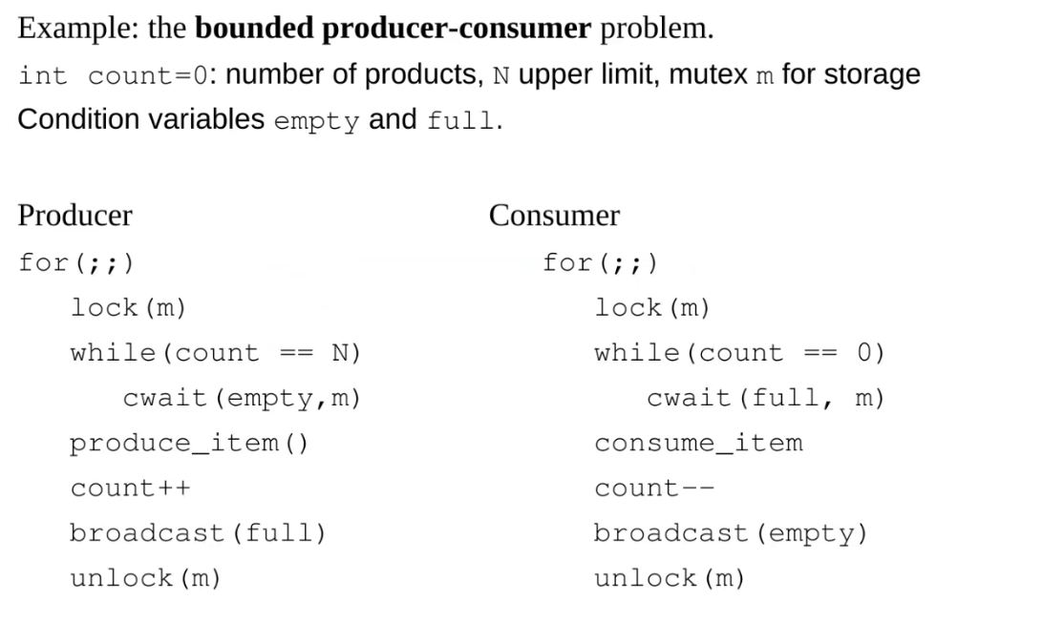

Dining Philosophers

Initialization:

